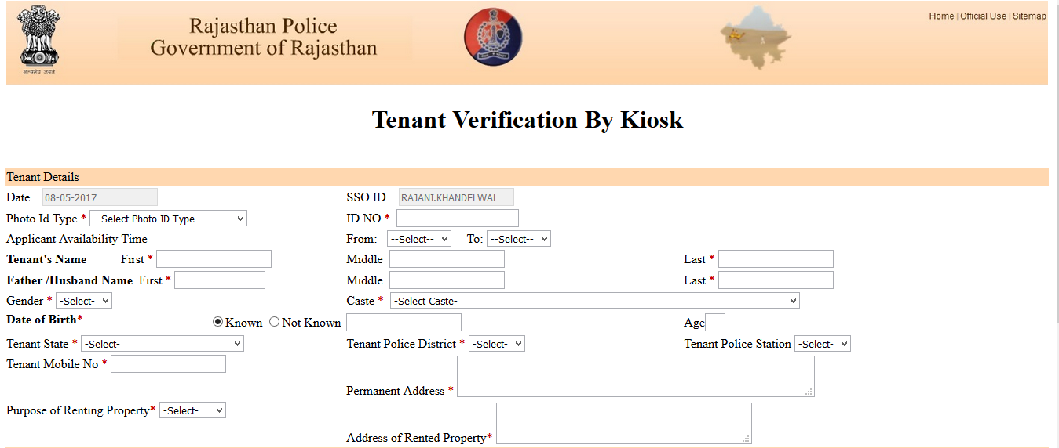

**Tenant Verification By Kiosk**

Tenant Details:

Date ____________

Photo Id Type*: _______________ ID No*: _____________________

Applicant Availability Time From:  __________   To: ______________

**Tenant's Name**           First * ___________________________Middle ___________________Last *__________________

**Father /Husband Name** First *_________________________Middle __________________Last *____________________

Gender *______________________ Caste * _________________________

**Date of Birth**\* Known DD/MM/YYYY: ________________________ Not Known Age___________

Tenant State * ______________________________Tenant Police District * _____________________________

Tenant Police Station_________________________________________________________________________

Tenant Mobile No *____________________________

Permanent Address *________________________________________________________________________________

_________________________________________________________________________________________________

__________________________________________________________________________________________________

Purpose of Renting Property* Business Factory Residence

School Shop Workshop

Address of Rented Property*___________________________________________________________________________

__________________________________________________________________________________________________

__________________________________________________________________________________________________

Landlord Details

**Landlord's Name**         First Name * ___________________ Middle__________________ Last *___________________

**Father /Husband Name** First Name *____________________ Middle _________________ Last *___________________

Landlord Mobile No *_________________________

Landlord's Address (Present Address) *___________________________________________________________________

___________________________________________________________________________________________________

___________________________________________________________________________________________________

Landlord Police District *_______________________________Landlord Police Station_____________________________

Referenced By _______________________________________

Upload Tenant Photo (.JPG Only)*

**Signature of Applicant**